Application form
for Replicants
of energy communities and collective
energy actions within DECIDE project

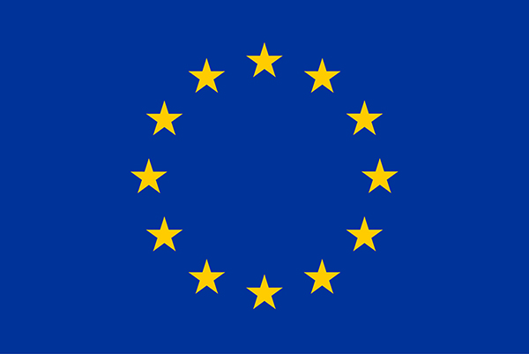
This project has received funding from the European Union’s Horizon 2020 research and innovation programme under grant agreement No 894255.
The sole responsibility for the content of this document lies with the DECIDE project and does not necessarily reﬂect the opinion of the European Union.

General information
Country: | [Insert MEMBER STATE NAME here]
Region or city of activity: | [Insert CITY or REGION here]
Name of Energy Community (EC) or Collective Action (CA): | [Insert here]
Are you EC or CA: | [Insert here]
Legal form of EC/CA: | [Insert here]
Organizational structure (if applicable: CEO, Board of directors, General assembly, etc.): | [Insert here]
Year of formation (if applicable): | [DD/MM/YYYY]
Number of members (if applicable): | [#]

Leading Organisation (Applicant) information

Name of the leading organization: | [Insert FULL LEGAL NAME here]
Type of organization: | [Public/private/NGO…]
Organization address: | [Name, Address Line 1, Post code, City, Country]
Organization website: | [Domain name here]
Organization contact person: | [Name Surname]
Contact person email address: | [email address here]
Contact person phone number: | [country code and number]

Supporting stakeholder one information

Name of the supporting group/organization: | [Insert FULL LEGAL NAME here]
Type of organization: | [Public/private/NGO…]
Organization/group address: | [Name, Address Line 1, Post code, City, Country]
Organization website: | [Doman name here]
Contact person: | [Name Surname]
Contact person email address: | [email address here]
Contact person phone number: | [country code + number]

Supporting stakeholder TWO information (if applicable)

Name of the supporting organization: | [Insert FULL LEGAL NAME here]
Type of organization: | [Public/private/NGO…]
Organization/group address: | [Name, Address Line 1, Post code, City, Country]
Organization website: | [Doman name here]
Contact person: | [Name Surname]
Contact person email address: | [email address here]
Contact person phone number: | [country code + number]

Energy community/Collective action specifications

Please explain the goal/vision of your EC/CA:
[Insert max. 1000 characters]
Under which existing/future law/regulation of your Member State are your activities covered? (non-compulsory field)
[Insert max. 1000 characters]
Provide an explanation of the role and capacity of the leading and supporting group/organization:
[Insert max. 1000 characters]
Do you receive any form of support/incentive (financial, funds, simplified procedure, cheaper technology)? If so, please explain nature and duration of this support:
[Insert max. 1000 characters]

Type of members in your EC/CA:
[Insert max. 1000 characters]
What is the membership procedure? How to become a member of your EC/CA, is it open to any interested party? (non-compulsory field)
[Insert max. 1000 characters]
Responsibilities of members of your EC/CA towards the EC/CA (monthly payment, participation, investment, etc.): (non-compulsory field)
[Insert max. 1000 characters]
List services that are offered to members of your EC/CA (renewable generation ownership, renewable energy supply, installation of PV, energy management, energy advice, etc.). Please specify the technology(ies) that are being utilized in your EC/CA:
[Insert max. 1000 characters]

Please explain how your EC/CA is benefiting its members or the (local) community:
[Insert max. 1000 characters]

Please explain your expectations from your EC/CA participating in DECIDE project as a Replicant and how will you contribute to DECIDE project objectives:
[Insert max. 1000 characters]

Which of the following energy activities is applicable for you (Multiple Choice)
Organized production and/or supply renewable energy (Electricity/heat)
Collective self-consumption in one or multiple buildings
Collective investment in renewable energy generation
Collective investment in energy efficiency measures/energy management
Collective service providers
Collective generation and trading of electricity
Energy positive districts
Energy islands
Financial aggregation and investment
Digital supply and demand response systems
Energy cooperatives
Generation- consumption communities
Cooperative financing of energy efficiency
Management of own generation, distribution and supply of energy
Collective use and purchase of e-mobility
Other: [Insert here]

Provided documents

Attachments’ confirmation:
[X] | Letter of Support from at least 1 stakeholder  (such as member, local government, supplier, energy company, building association, NGO)
Checkbox (mandatory): I confirm that I have read the DECIDE Replicant information sheet, understand and agree with our involvement in the DECIDE project.
Checkbox (mandatory): By submitting I confirm the validity of the data provided. Further, I agree and allow DECIDE project’s “Call for expression of interest for DECIDE replicants” organizers (consisting of the DECIDE consortia) to electronically collect, save, process and evaluate the submission material directly connected to the purpose of the DECIDE project. The submission material includes personal data (name, mail address, address, phone number, position) of the applicant for evaluating the applications and contacting the applicant. Your personal data will not be forwarded to any other party than the project consortia in any case without prior consultation. Your personal data will be handled confidentially and according to the European General Data Protection Regulation (GDPR).

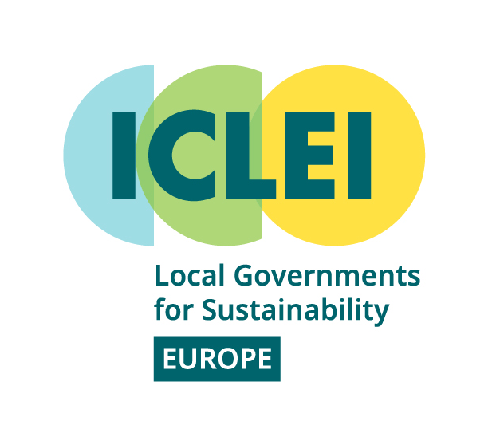
This project has received funding from the European Union’s Horizon 2020 research and innovation programme under grant agreement No 894255. The sole responsibility for the
content of this document lies with the DECIDE project and does not necessarily reﬂect
the opinion of the European Union.

Mr. or Mrs.
Company name
Phone number
E-Mail
PARTNERS
CONTACT

If unsure, you may use the self-assessment tool: https://agatasmok.typeform.com/to/PryKIzIT
The supporting organisation is the one that provided Letter of support

